**4.A.Creating Databases using MongoDB, DynamoDB, Voldemort Key-Value Distributed Data Store Hbase and Neo4j.**

**Aim:**

To Create Databases using MongoDB, DynamoDB, Voldemort Key-Value Distributed Data Store Hbase and Neo4j.

**Procedure:**

**MongoDB (Create Database)** const { MongoClient } = require('mongodb');

// Import the MongoClient class from the 'mongodb' library.

async function createDatabase() { const uri = "mongodb://127.0.0.1:27017";

// Connection string to connect to the MongoDB server running locally.

const client = new MongoClient(uri);

// Create a new MongoClient instance to connect to the server.

try { await client.connect();

// Connect to the MongoDB server.

console.log("Connected to MongoDB");

// Log a success message.

const db = client.db("MyMongoDB");

// Create a database named 'MyMongoDB'. If it doesn't exist, MongoDB will create it when data is added.

console.log("Database created: MyMongoDB");

// Log that the database has been created.

} catch (err) { console.error(err);

// Handle and log any errors that occur during the connection or database creation process.

} finally { await client.close();

// Close the connection to the MongoDB server to free up resources.

}

}

createDatabase();

// Invoke the function to execute the database creation logic.

**OUTPUT:**



**DynamoDB (Create Table)** const AWS = require('aws-sdk');

// Import the AWS SDK library for interacting with AWS services. AWS.config.update({ region: "us-east-1",

// Specify the AWS region where DynamoDB is running.

endpoint: "http://localhost:8000"

// Use the local DynamoDB instance endpoint.

});

const dynamoDB = new AWS.DynamoDB();

// Create a DynamoDB service object. const params = {

TableName: "MyDynamoDBTable",

// Name of the table to be created.

KeySchema: [

{ AttributeName: "id", KeyType: "HASH" }

// Define the primary key schema. 'id' is the partition key.

],

AttributeDefinitions: [

{ AttributeName: "id", AttributeType: "S" }

// Define the data type of the 'id' attribute as a string.

],

ProvisionedThroughput: {

ReadCapacityUnits: 1,

// Set the read capacity units for the table.

WriteCapacityUnits: 1

// Set the write capacity units for the table.

} };

dynamoDB.createTable(params, (err, data) => {

// Call the `createTable` method to create the table using the defined parameters.

if (err) { console.error("Error creating table:", JSON.stringify(err, null, 2)); // Log an error message if table creation fails.

} else { console.log("Table created:", JSON.stringify(data, null, 2));

// Log the success message with table details.

}

});

**OUTPUT**

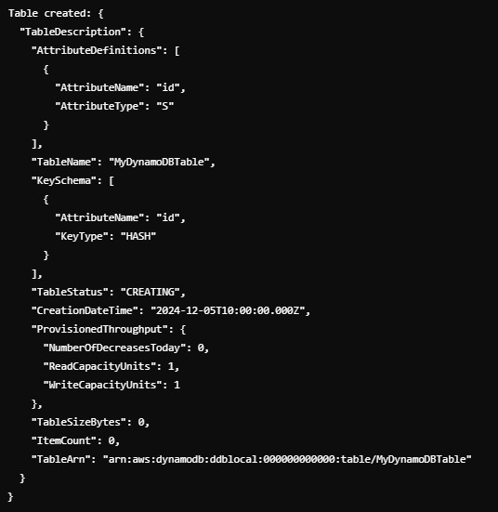

**Voldemort (Create Store)** const fetch = require('node-fetch');

// Import the 'node-fetch' library for making HTTP requests.

async function createStore() { const url = "http://localhost:8080/stores"; // Endpoint for managing Voldemort stores. const storeConfig = `

<store>

<name>MyVoldemortStore</name>

<!-- Name of the key-value store being created -->

<key-serializer>

<type>string</type>

<!-- Specify that the keys are serialized as strings -->

</key-serializer>

<value-serializer>

<type>string</type>

<!-- Specify that the values are serialized as strings -->

</value-serializer>

</store>`;

try { const response = await fetch(url, { method: "POST",

// Use POST method to send the store creation request.

headers: { "Content-Type": "application/xml" },

// Specify that the request body is in XML format.

body: storeConfig

// Send the store configuration as the request body.

});

if (response.ok) { console.log("Store created successfully"); // Log a success message if the store is created.

} else { console.error("Error creating store:", response.statusText); // Log the response's error status if store creation fails.

}

} catch (err) { console.error("Request failed:", err); // Handle and log network or other errors.

}

}

createStore();

// Invoke the function to create the store.

OUTPUT



**HBase (Create Table)** const HBase = require('hbase-client'); // Import the HBase client library.

const config = { zookeeperHosts: ["localhost"], // Define the Zookeeper hosts for HBase.

zookeeperRoot: "/hbase",

// Specify the Zookeeper root path for HBase.

rpcTimeout: 30000,

// Timeout for RPC (Remote Procedure Call) operations.

callTimeout: 30000, reconnectTimeout: 30000

// Timeout for reconnecting to the server.

};

const client = HBase.create(config);

// Create a connection to the HBase server with the specified configuration. async function createTable() { const tableDescriptor = { name: "MyHBaseTable",

// Define the name of the table.

families: [{ name: "data" }]

// Specify a column family named 'data'.

};

try { await client.createTable(tableDescriptor);

// Call the createTable method with the table descriptor.

console.log("Table created: MyHBaseTable"); // Log a success message if the table is created.

} catch (err) { console.error("Error creating table:", err); // Log any errors encountered during table creation.

} finally { client.close();

// Close the HBase client connection.

}

}

createTable();

// Invoke the function to execute the table creation logic.

**OUTPUT**



**Neo4j (Create Database)** const neo4j = require('neo4j-driver'); // Import the Neo4j driver library for Node.js.

const driver = neo4j.driver("bolt://localhost:7687", neo4j.auth.basic("neo4j", "password"));

// Create a driver instance to connect to the Neo4j database. Replace 'password' with your actual password.

const session = driver.session();

// Open a new session to interact with the database.

async function createDatabase() {

try {

await session.run('CREATE (n:Database {name: "MyNeo4jDB"}) RETURN n');

// Execute a Cypher query to create a node with the label 'Database' and a property 'name'.

console.log("Database node created: MyNeo4jDB");

// Log a success message when the node is created.

} catch (err) { console.error("Error creating database:", err);

// Log any errors encountered during the database creation process.

} finally { await session.close();

// Close the session.

await driver.close();

// Close the driver to free resources.

}

}

createDatabase();

// Invoke the function to execute the database creation logic.

**OUTPUT:**



**Result:**

Thus the Creation of Databases using MongoDB, DynamoDB, Voldemort Key-Value Distributed Data Store Hbase and Neo4j has be completed successfully

**4.B.Writing simple queries to access databases created using MongoDB, DynamoDB, Voldemort Key-Value Distributed Data Store Hbase and Neo4j.**

**Aim:**

To Write simple queries to access databases created using MongoDB, DynamoDB, Voldemort Key-Value Distributed Data Store Hbase and Neo4j.

**Procedure:**

**Prerequisites**

1. **Install Node.js**: Make sure you have Node.js installed. You can download it from [Node.js official website.](https://nodejs.org/)
2. **Set Up VS Code**: Download and install [Visual Studio Code.](https://code.visualstudio.com/)
3. **Install Extensions**:

o MongoDB: [MongoDB for VS Code](https://marketplace.visualstudio.com/items?itemName=mongodb.mongodb-vscode) o Neo4j: [Neo4j VS Code Extension](https://marketplace.visualstudio.com/items?itemName=neo4j.neo4j-vscode)

**Step-by-Step Setup Instructions**

1. **Initialize a Node.js Project**

Open VS Code, create a new folder for your project, and initialize a Node.js project.

# Open terminal in VS Code and run: npm init -y

This will create a package.json file where your project dependencies are listed.

1. **Install Required Packages**

Install the necessary npm packages for each database.

# MongoDB npm install mongodb

# DynamoDB (AWS SDK)

npm install aws-sdk

# Voldemort (REST calls using axios) npm install axios

# HBase (hbase-client) npm install hbase-client # Neo4j npm install neo4j-driver

**3. Configure JavaScript Code for Each Database**

For each database, create a separate JavaScript file and add the respective code for operations.

**MongoDB Setup (Using mongodb package)**

Create a file named mongodb.js and add the following code:

const { MongoClient } = require('mongodb');

const uri = "mongodb://localhost:27017"; // MongoDB connection string

const client = new MongoClient(uri);

async function run() { try {

await client.connect(); const database = client.db("testDB");

const students = database.collection("students");

// Insert Data

await students.insertOne({ name: "Alice", age: 22, major: "Computer Science" });

// Retrieve All Documents

const allStudents = await students.find({}).toArray(); console.log("All Students:", allStudents);

// Retrieve Specific Documents

const specificStudent = await students.find({ age: 22 }).toArray(); console.log("Specific Student:", specificStudent);

// Update a Document

await students.updateOne({ name: "Alice" }, { $set: { major: "Mathematics" } });

// Delete a Document

await students.deleteOne({ name: "Alice" });

} finally {

await client.close();

} }

run().catch(console.dir);

To run this file, open the terminal and execute:

node mongodb.js

**Output:**

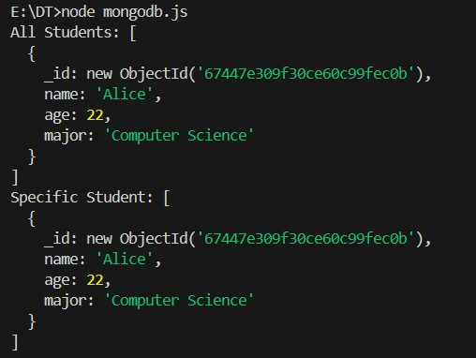

**DynamoDB Setup (Using aws-sdk)**

Create a file named dynamodb.js and add the following code:

const AWS = require('aws-sdk');

// Configure DynamoDB Local AWS.config.update({ region: "us-west-2", endpoint: "http://localhost:8000"

});

const dynamodb = new AWS.DynamoDB.DocumentClient();

const tableName = "Students";

async function run() {

// Insert Data

await dynamodb.put({ TableName: tableName,

Item: { StudentID: "123", Name: "Alice", Age: 22, Major: "Computer Science" } }).promise();

// Retrieve a Specific Item const item = await dynamodb.get({

TableName: tableName,

Key: { StudentID: "123" }

}).promise();

console.log("Retrieved Item:", item);

// Update an Item await dynamodb.update({ TableName: tableName,

Key: { StudentID: "123" },

UpdateExpression: "SET Major = :m",

ExpressionAttributeValues: { ":m": "Mathematics" }

}).promise();

// Delete an Item await dynamodb.delete({ TableName: tableName,

Key: { StudentID: "123" }

}).promise();

}

run().catch(console.error);

Run it using:

node dynamodb.js

**Output:**

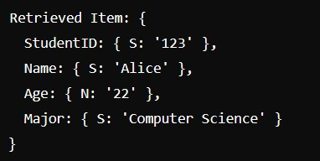

**Voldemort Setup (Using axios)**

Create a file named voldemort.js and add the following code:

const axios = require('axios');

const baseUrl = "http://localhost:8081/stores/students/";

async function run() { // Insert Data await axios.post(baseUrl, {

key: "123",

value: { name: "Alice", age: 22, major: "Computer Science" }

});

// Retrieve Data

const { data } = await axios.get(`${baseUrl}123`); console.log("Retrieved Data:", data);

// Delete Data

await axios.delete(`${baseUrl}123`);

}

run().catch(console.error);

Run it with:

node voldemort.js

**Output:**

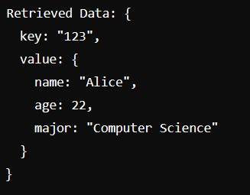

**HBase Setup (Using hbase-client)**

Create a file named hbase.js and add the following code:

const HBase = require('hbase-client');

const client = HBase.create({ zookeeperHosts: ['localhost:2181'], zookeeperRoot: '/hbase'

});

async function run() { // Insert Data await client.put('students', '1', [ { column: 'info:name', $: 'Alice' },

{ column: 'info:age', $: '22' },

{ column: 'info:major', $: 'Computer Science' }

]);

// Retrieve Data for a Row

const result = await client.getRow('students', '1'); console.log("Row Data:", result);

// Delete Data

await client.delete('students', '1', 'info:major');

client.close();

}

run().catch(console.error);

Run with:

node hbase.js

**Output:**

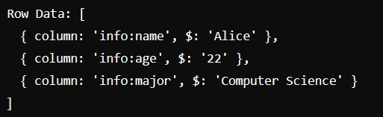

**Neo4j Setup (Using neo4j-driver)**

Create a file named neo4j.js and add the following code:

const neo4j = require('neo4j-driver'); const uri = 'bolt://localhost:7687'; const user = 'neo4j';

const password = 'your_password';

const driver = neo4j.driver(uri, neo4j.auth.basic(user, password)); const session = driver.session(); async function run() { // Create a Node

await session.run("CREATE (a:Student {name: 'Alice', age: 22, major: 'Computer Science'})");

// Retrieve All Nodes

const result = await session.run("MATCH (s:Student) RETURN s"); result.records.forEach(record => {

console.log("Retrieved Node:", record.get('s').properties); });

// Update a Node

await session.run("MATCH (s:Student {name: 'Alice'}) SET s.major = 'Mathematics'");

// Delete a Node

await session.run("MATCH (s:Student {name: 'Alice'}) DELETE s");

await session.close(); driver.close();

} run().catch(console.error); Run with: node neo4j.js

**Output:**



**Result:**

Thus Writing simple queries to access databases created using MongoDB, DynamoDB, Voldemort Key-Value Distributed Data Store Hbase and Neo4j has been completed successfully.